Assignment 25.5

1. Write a hive query to list top 5 residency details which lie in the budget of 60000-120000, an area more than 1450, sold after 17th may, min bedroom 3 and, min bathroom 2.

Also include columns in following order City,Baths,Sq_feet,Price,flat_type,Beds respectively. You can download the dataset from the link below: https://drive.google.com/file/d/0B1QaXx7tpw3SNDVoWEhPTk1SSjQ/view The first line of the dataset is the dataset description. You need to create a hive table with that schema.

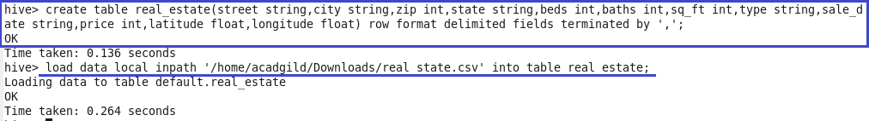

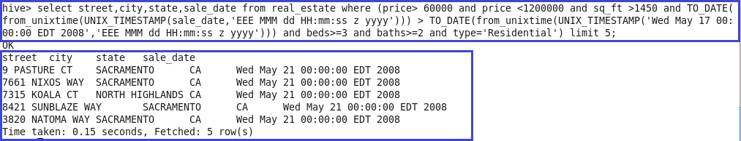

2. Write a hive query to separate list of residential apartments with more than 2 beds.

In output,only the first 30 records are displayed.

